

CUSTOMER CARE REGISTRY

**PROBLEM-SOLUTION FIT**

TEAM DETAILS:



**Team No :** PNT2022TMID51192

**College Name :** AAA College of Engineering & Technology

**Department :** Computer Science & Engineering

# PROJECT MEMBERS :

* SRIRAM SELVAKUMAR S
* G SIVA ANANDAVEL
* AAKARSH S U
* SURAJ RAM S

Problem-Solution Fit 2

PROJECT DESIGN PHASE –I

PROPOSED SOLUTION

|  |  |
| --- | --- |
| **DATE** | **24 September 2022** |
| **TEAM ID** | PNT2022TMID51192 |
| **PROJECT NAME** | CUSTOMER CARE REGISTRY |
| **MAXIMUM MARKS** | 2 Marks |

Problem-Solution Fit 3

PROJECT DESIGN PHASE –I (PROBLEM-SOLUTION FIT)

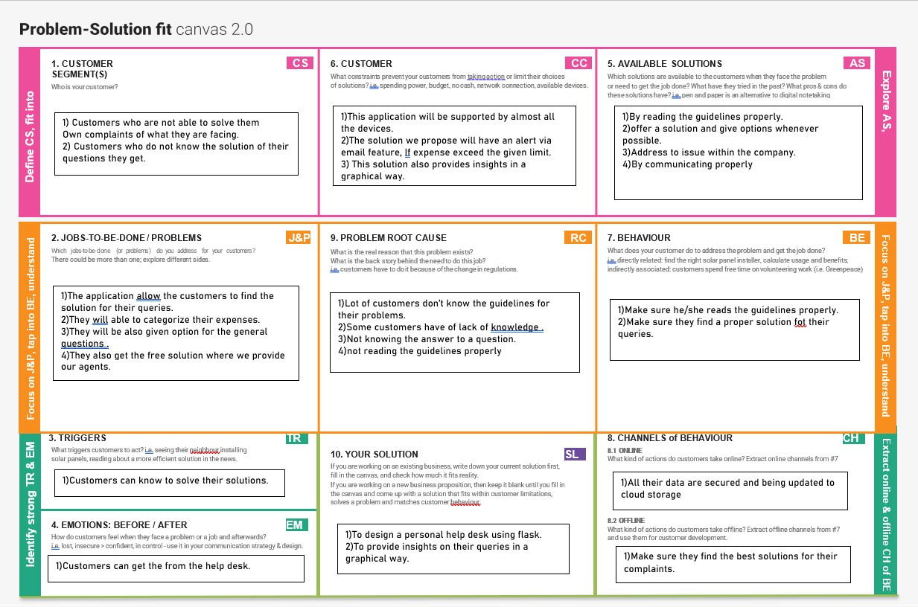

Problem-Solution Fit 4



**Thank you**